YEAR 11 GENERAL HUMAN BIOLOGY

Name: _________________________________________
Task 5: Circulatory and Respiratory Systems Test – 7%

Multiple Choice 15 Marks
Short Answer 30 Marks
Total 45 Marks

Section A: Multiple choice (15 Marks)
Answer all questions by circling the most correct answer on this multiple choice answer sheet.

1. a b c d 9. a b c d
2. a b c d 10. a b c d
3. a b c d 11. a b c d
4. a b c d 12. a b c d
5. a b c d 13. a b c d
6. a b c d 14. a b c d
7. a b c d 15. a b c d
8. a b c d

Part 1: Multiple Choice (15 marks)
Please circle the correct answer on the multiple choice answer sheet provided
- Wind pipe is a common name for:
a) Larynx
b) Pharynx
c) Trachea
d) Diaphragm

- During exhalation the:
a) diaphragm lowers
b) ribs move upwards and outwards
c) size of the thoracic cavity increases
d) pressure inside the thoracic cavity increases

- One function of white blood cells is to
a) assist in the clotting of blood
b) carry haemoglobin
c) engulf/remove bacteria
d) transport carbon dioxide

- The valves between the chambers of the heart ensures:
a) blood is maintained at a constant pressure
b) blood is pumped at all times
c) blood flows in one direction
d) all chambers of the heart can fill with blood simultaneously

- Which of the following are involved in pulmonary circulation?

- Right ventricle, pulmonary trunk, left atrium

- Superior vena cava, right atrium, right ventricle

- Left ventricle, aorta, pulmonary trunk

- Right atrium, right ventricle, left atrium

- The strong tendinous cords called the chordae tendinae

- Strengthen the septum
- Support the pericardium surrounding the heart
- Prevent the valves from turning inside out
- Slow down the flow of blood through the heart

- The liquid part of the blood is called

- Platelets
- Plasma
- Cytoplasm
- Haemoglobin

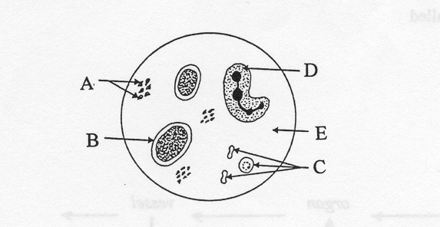
- In the diagram above of human blood seen through a microscope, which structure is a red blood cell

- A
- B
- C
- D

- Which component of the blood is important in blood clotting?

- A
- B
- C
- All of the above

- Red blood cells are produced by

- Bone marrow
- Liver
- Thymus gland
- Blood

- Which one of the following statements about the function of blood is not true? Blood

- Carries hormones from one part of the body to another
- Transports waste products away from areas of high concentrations
- Transports oxygen towards body cells
- Provides readily available energy in the form of ATP to the cells

- The blood vessels found in a mammalian system that are thin enough to allow diffusion to occur across their walls are called

- veins
- capillaries
- arteries
- alveoli

The data presented below was recorded in an experiment where a subject breathed in and out of a paper bag and the percentage of carbon dioxide in the air in the bag was recorded. The rate and depth of breathing of the subject was also measured.

 | Normal breathing | After rebreathing
% of CO2 in bag | 0.4 | 1.52
Depth of breathing | 673 mL | 794 mL
Rate of breathing | 14/min | 15/min

Given the data above the volume of air breathed by the subject in one minute of normal breathing is

9422L

9422mL

40L

40mL

What was the percentage change in the depth of breathing between normal breathing and rebreathing?

8.4%

84.7%

1.1%

40.6%

Exchange of gases in the alveolus of the mammalian lung is by

Osmosis

Diffusion

Capillary force

Dialysis

Section B Short Answer 30 Marks
Question1
Name vessels

- A______________________________________

B______________________________________

C______________________________________

D______________________________________
(4 marks)

(b) (i) State which vessel(s) carry oxygenated blood using the letter(s) indicated in the diagram above.
____________________________________________________________________________________________________________________________
(2 mark)

(c) The diagram below shows the cross section of an artery and a vein respectively.
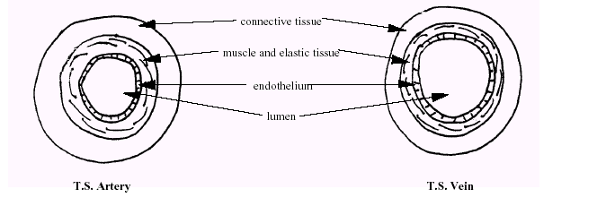
(i) What is the role of the elastic tissue that makes up the arteries?
(2 marks)

_______________________________________________________________

_______________________________________________________________

_______________________________________________________________

(ii) Why do we describe an artery and a vein as organs? (2 marks)

_______________________________________________________________

_______________________________________________________________

_______________________________________________________________

(iii) What differences in structure are there between an artery and a vein? (3 marks)

_______________________________________________________________

_______________________________________________________________

_____________________________________________________________________________________________________________________________________________________________________________________________
(iv) Describe the structure of a capillary (2 marks)

_______________________________________________________________

_______________________________________________________________

_______________________________________________________________

_______________________________________________________________

_______________________________________________________________

(v) Consider the effects of a heart attack on the function of the organ above. Imagine if the heart attack resulted in damage to the muscular wall of the left ventricle so that the left ventricle was no longer able to pump the same amount of blood as it did in normal circumstances. What would be the effect on the individual concerned? Explain your answer.
(2 marks)
_________________________________________________________________

_________________________________________________________________

_________________________________________________________________

_________________________________________________________________

Question 2
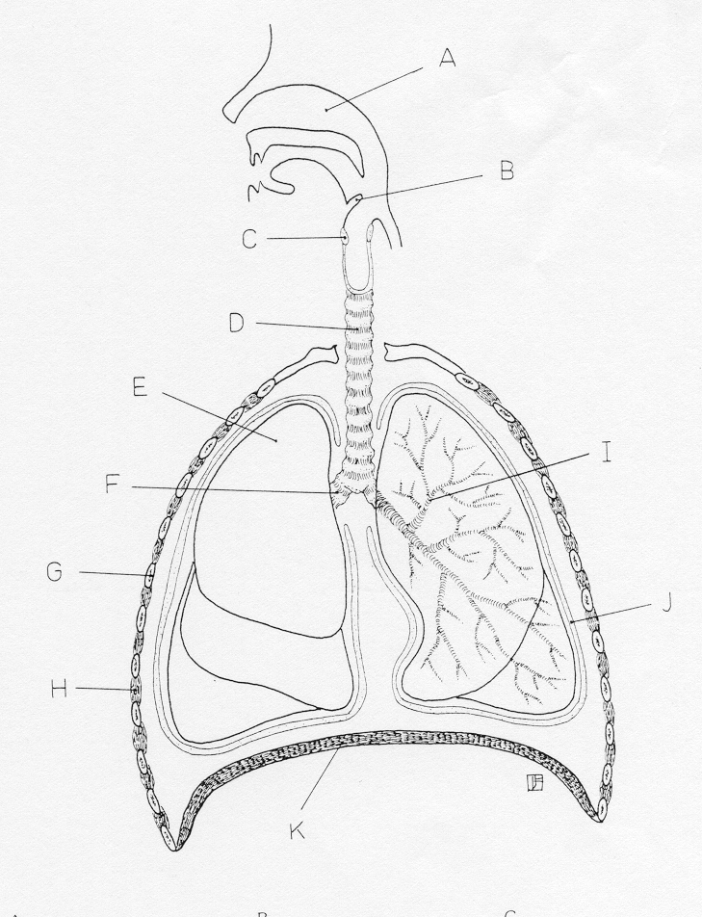

E ______________________ C ___________________
D ______________________ F ___________________
I ______________________ G ___________________
J ______________________ K ___________________
(4 marks)

- List three features that a respiratory surface has in order to maximise the diffusion of gases.

________________________________________________________________

________________________________________________________________

_________________________________________________________________

_________________________________________________________________

_________________________________________________________________
(3 marks)

- Describe the bronchioles of an individual having an asthma attack.
(2 marks)
_______________________________________________________________________________________________________________________________________________________________________________________________________________________________________________________________________________________________________________________________________________

- Give the word equation for aerobic and anaerobic respiration and describe two differences between them.
(4 marks)
Aerobic_____________________________________________________________Anaerobic________________________________________________________________________________________________________________________________________________________________________________________________________________________________________________________________________________________________________________________________________________________________________________________________________________________________________________________________________________________________________________________________________________

